**High Performance Computing**

**System Administrator**



**CENTRE FOR DEVELOPMENT OF ADVANCED COMPUTING PUNE**

**CASE STUDY**

**Submitted By:**

**Suraj Bhujbal (230340127012)**

**Nitya Vats (230340127004)**

**Siddhesh Kachkure (230340127010)**

**Indrajeet Kumar (230340127036)**

**AIM**

Build a Two node Stateless HPC-Cluster using Warewulf with PBS, Ganglia, and LDAP

Required Machine: Centos7 Virtual Machine

Specification: 8 GB RAM, 4 Processor, 100 HDD

Network Adapter: NAT: 192.168.44.172, Host-Only: 10.0.0.129

**WareWulf**

**On Master**

**# systemctl stop firewalld.service**

**# systemctl disable firewalld.service**

**# hostnamectl set-hostname master**

**# vi /etc/selinux/config**

SELINUX=disabled

**Warewulf Installation**

**# yum install -y https://repo.ctrliq.com/rhel/8/ciq-release.rpm**

**# yum install -y warewulf**

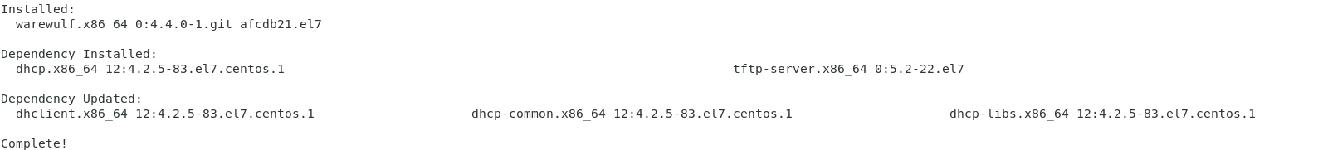

**# vim /etc/warewulf/warewulf.conf**

WW_INTERNAL: 43

ipaddr: 10.0.0.129 #(host ip address of master node)

netmask: 255.0.0.0

network: 10.0.0.0

warewulf:

port: 9873

secure: false

update interval: 60

autobuild overlays: true

host overlay: true

syslog: false

datastore: ""

dhcp:

enabled: true

template: default

range start: 10.0.0.1

range end: 10.0.0.100

systemd name: dhcpd

tftp:

enabled: true

tftproot: ""

systemd name: tftp

nfs:

enabled: true

export paths:

- path: /home

export options: rw,sync

mount options: defaults

mount: true

- path: /opt

export options: ro,sync,no_root_squash

mount options: defaults

mount: false

systemd name: nfs-server

**# wwctl configure --all**

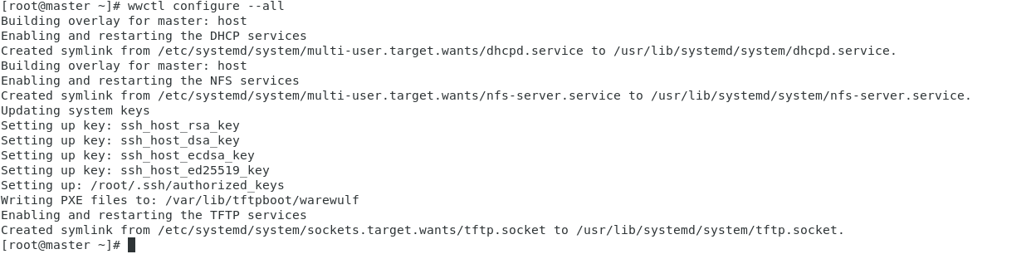

**# systemctl status dhcpd**

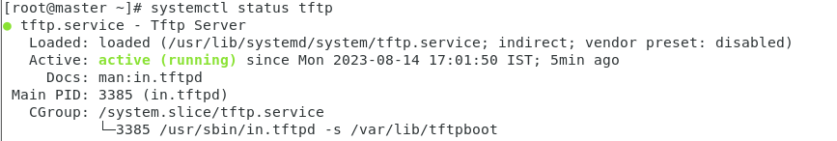

**# systemctl status tftp**

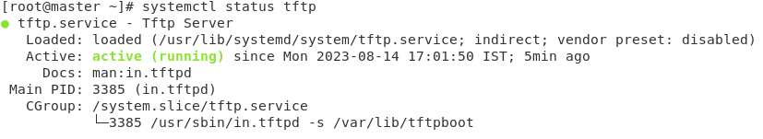

**# systemctl status nfs-server**

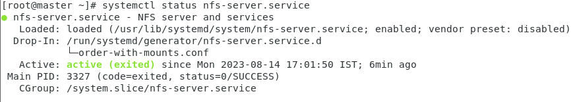

**# systemctl start warewulfd && systemctl enable warewulfd && systemctl status warewulfd**

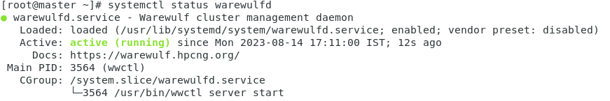

**# wwctl server status**



**# more /var/log/warewulfd.log**



**# wwctl container import docker://ghcr.io/hpcng/warewulf-centos:7 centos-7**

**# wwctl container list**



**# wwctl container exec centos-7 /bin/bash**

**# [centos-7] Warewulf> exit**

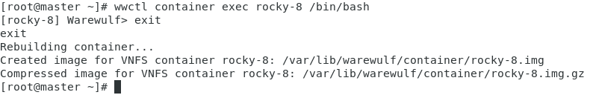

**# wwctl container list**



**# wwctl** **profile** **list -a**

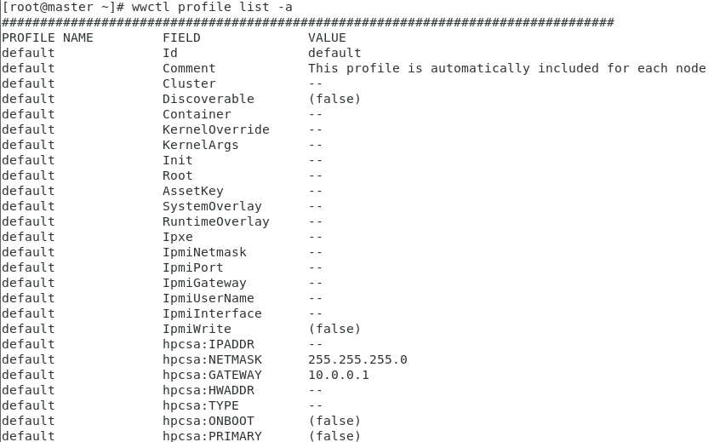

**# wwctl container import docker://registry.opensuse.org/science/warewulf/tumbleweed/containerfile/kernel:latest tw**

**#** **wwctl kernel import -DC tw**

**Now adding Node**

**# wwctl node add n001 -I 10.0.0.2**

**#** **wwctl node set --container centos-7 n001**



**# wwctl node set --kerneloverride tw n001 **

**# wwctl kernel list**



**# wwctl node set --netdev ens36 --hwaddr 00:0C:29:1E:E3:5D --ipaddr 10.0.0.2 --netmask 255.255.255.0 cn001**

Now restart booted Node

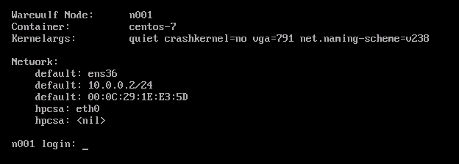

**Here we have successfully booted 2 nodes by Warewulf provisioning tool**

**Open LDAP**

**On Master**

**# systemctl stop firewalld && systemctl disable firewalld && systemctl status firewalld**

**# vi /etc/selinux/config**

SELINUX=disabled

**# vi /etc/hosts**

Add hosts ip address and their hostname in the file

**# yum -y install openldap-servers openldap-clients**

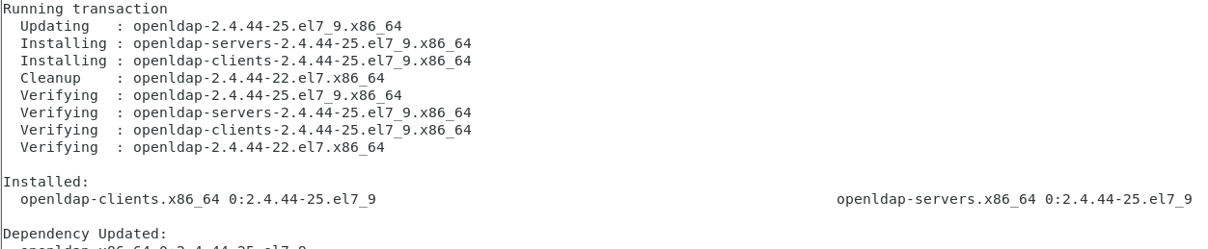

**# cp /usr/share/openldap-servers/DB_CONFIG.example /var/lib/ldap/DB_CONFIG**

**# systemctl start slapd && systemctl enable slapd && systemctl status slapd**

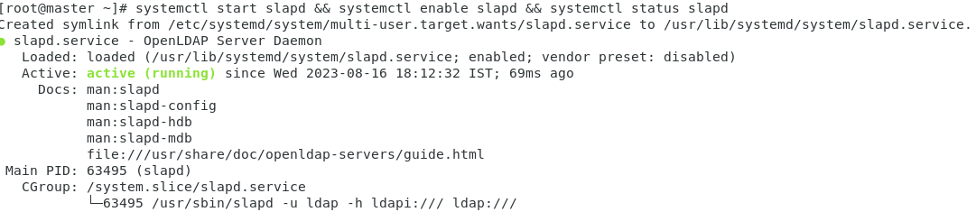

**# slappasswd**

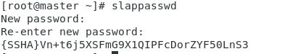

{SSHA}Vn+t6j5XSFmG9X1QIPFcDorZYF50LnS3

**# vi chrootpw.ldif**

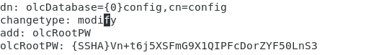

**# ldapadd -Y EXTERNAL -H ldapi:/// -f chrootpw.ldif**

**# ldapadd -Y EXTERNAL -H ldapi:/// -f /etc/openldap/schema/cosine.ldif**

**# ldapadd -Y EXTERNAL -H ldapi:/// -f /etc/openldap/schema/nis.ldif**

**# ldapadd -Y EXTERNAL -H ldapi:/// -f /etc/openldap/schema/inetorgperson.ldif**

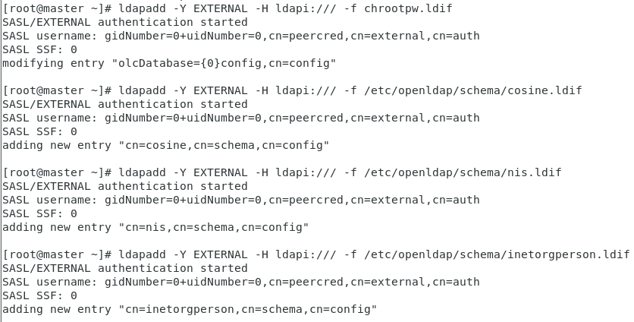

**# vi chdomain.ldif**

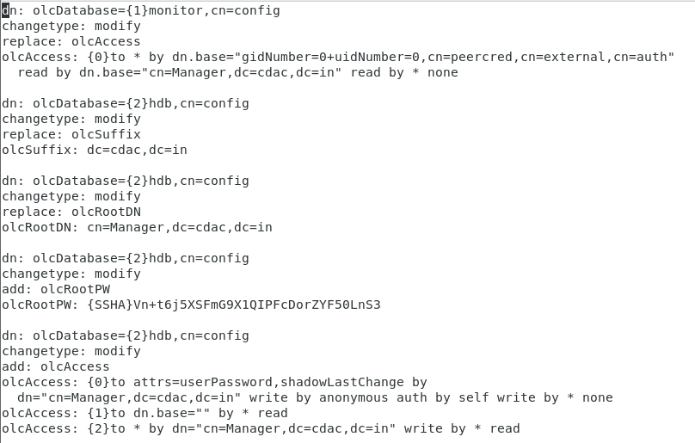

**# ldapmodify -Y EXTERNAL -H ldapi:/// -f chdomain.ldif**

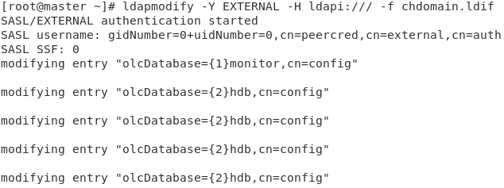

**# vi basedomain.ldif**

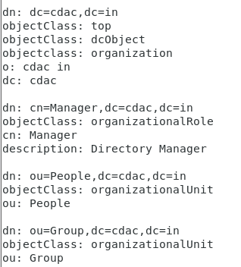

**# ldapadd -x -D cn=Manager,dc=cdac,dc=in -W -f basedomain.ldif**

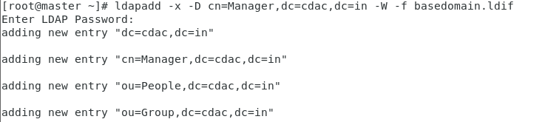

**# vi ldapuser.ldif**

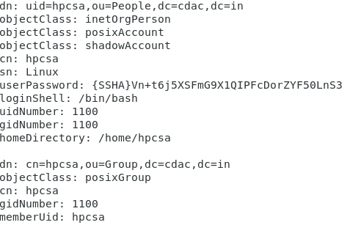**’**

**# ldapadd -x -D cn=Manager,dc=cdac,dc=in -W -f ldapuser.ldif**

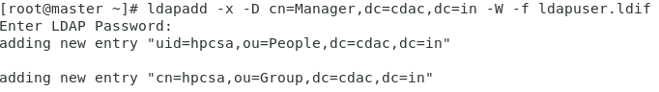

**On Client**

**# systemctl stop firewalld && systemctl disable firewalld && systemctl status firewalld**

**# vi /etc/selinux/config**

SELINUX=disabled

**# yum -y install openldap-clients nss-pam-ldapd**

**# authconfig --enableldap --enableldapauth --ldapserver=master --ldapbasedn="dc=cdac,dc=in" --enablemkhomedir --update**

**# systemctl restart nslcd && systemctl status nslcd**

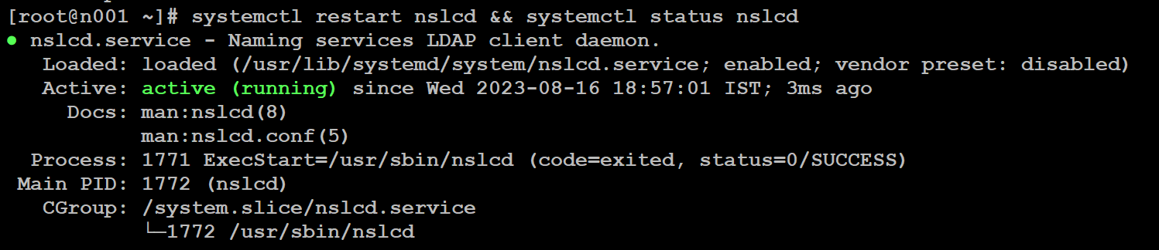

**# ldapsearch -x**

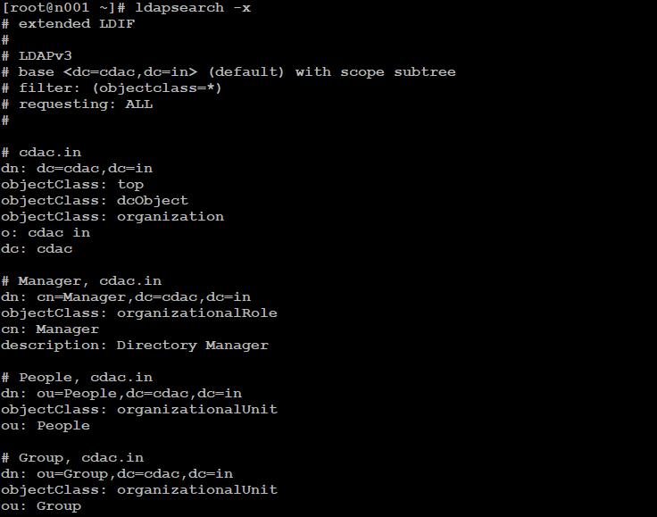

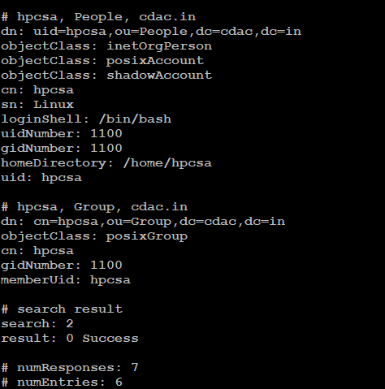

**# cat /etc/nslcd.conf**

**# cat /etc/nsswitch.conf**

**# getent passwd**



**# ssh hpcsa@n001**

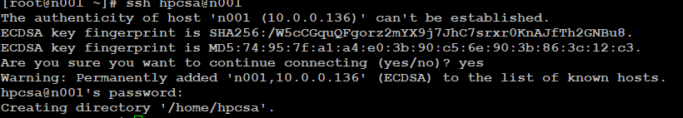

**Ganglia**

**On Master**

**# systemctl stop firewalld && systemctl disable firewalld && systemctl status firewalld**

**# vi /etc/selinux/config**

SELINUX=disabled

**# yum install**[**http://build.openhpc.community/OpenHPC:/1.3/CentOS_7/x86_64/ohpc-release-1.3-1.el7.x86_64.rpm**](http://build.openhpc.community/OpenHPC:/1.3/CentOS_7/x86_64/ohpc-release-1.3-1.el7.x86_64.rpm)

**# yum install ohpc-ganglia -y**

**# vim /etc/ganglia/gmetad.conf**



**# systemctl start gmetad.service gmond.service httpd.service && systemctl status gmetad.service gmond.service httpd.service && systemctl enable gmetad.service gmond.service httpd.service**

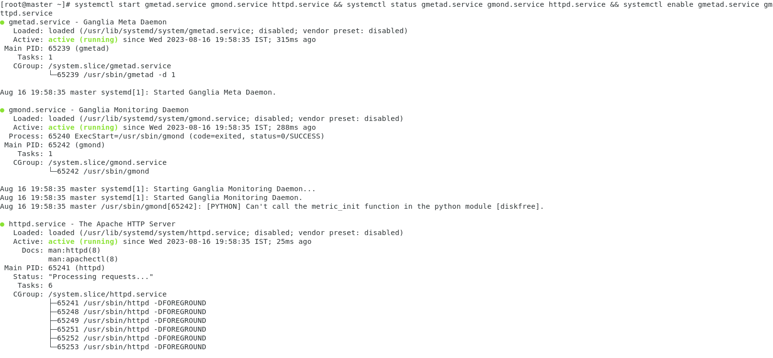

**# vi /etc/ganglia/gmond.conf**

**enter cluster name**

** enter master ip**

**comment these lines**

**# systemctl restart gmond && systemctl status gmond**

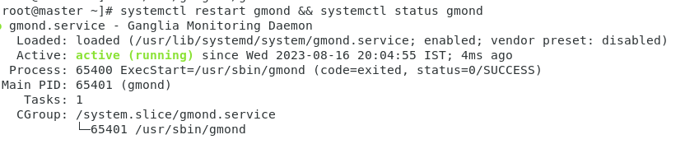

**On Client**

**# yum install http://build.openhpc.community/OpenHPC:/1.3/CentOS_7/x86_64/ohpc-release-1.3-1.el7.x86_64.rpm -y**

**# yum install ganglia-gmond-ohpc -y**

**# vi /etc/ganglia/gmond.conf**





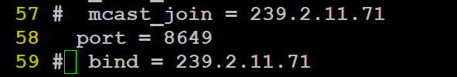

**# systemctl restart gmond && systemctl status gmond**

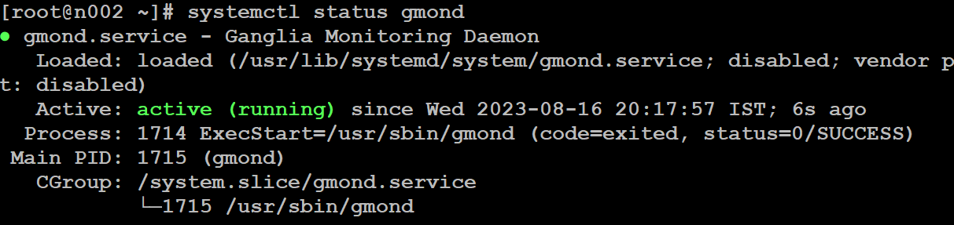

**Now open web browser and enter ip address of master/ganglia/**

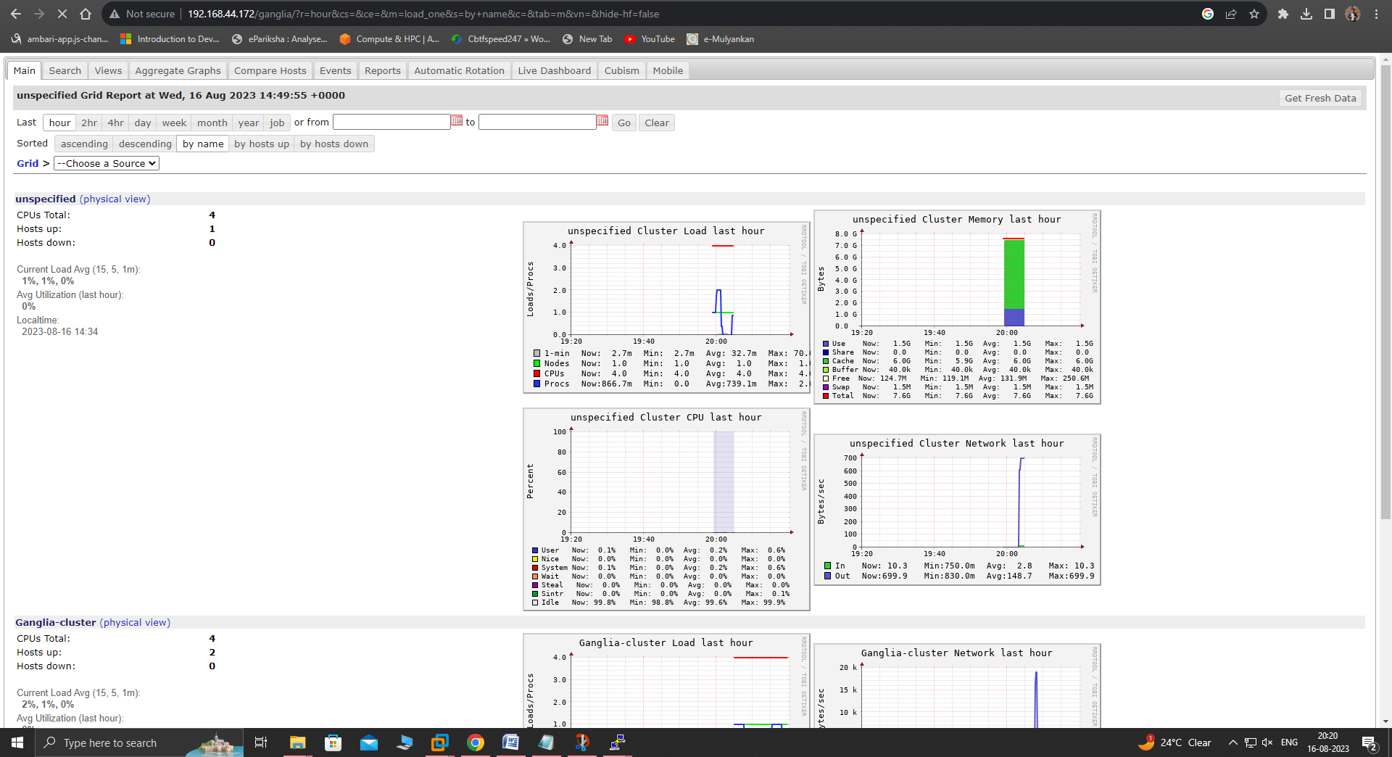

**PBS**

**On Master**

**# systemctl stop firewalld && systemctl disable firewalld && systemctl status firewalld**

**# vi /etc/selinux/config**

SELINUX=disabled

**# vi /etc/hosts**

Add hosts ip address and their hostname in the file

**# ssh-keygen**

**# ssh-copy-id root@n001**

**# ssh-copy-id root@n002**

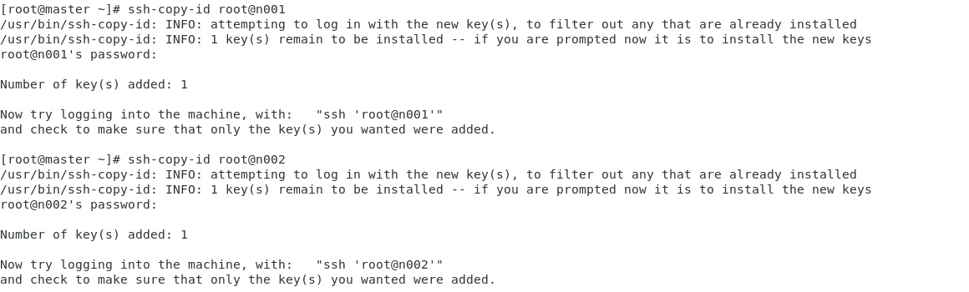

**# yum install git -y**

**# git clone https://github.com/openpbs/openpbs.git**

**# yum group install "Development Tools"**

**# cd openpbs**

**# mv /root/openpbs/ /root/openpbs-23.06.06**

**# mkdir -p /root/rpmbuild/SOURCES**

**# tar -cvf /root/rpmbuild/SOURCES/openpbs-23.06.06.tar.gz openpbs-23.06.06**

**# cd openpbs-23.06.06/**

**# yum install libtool-ltdl-devel hwloc-devel libXt-devel libedit-devel libical-devel ncurses-devel postgresql-devel postgresql-contrib python3-devel tcl-devel tk-devel zlib-devel expat-devel openssl-devel -y**

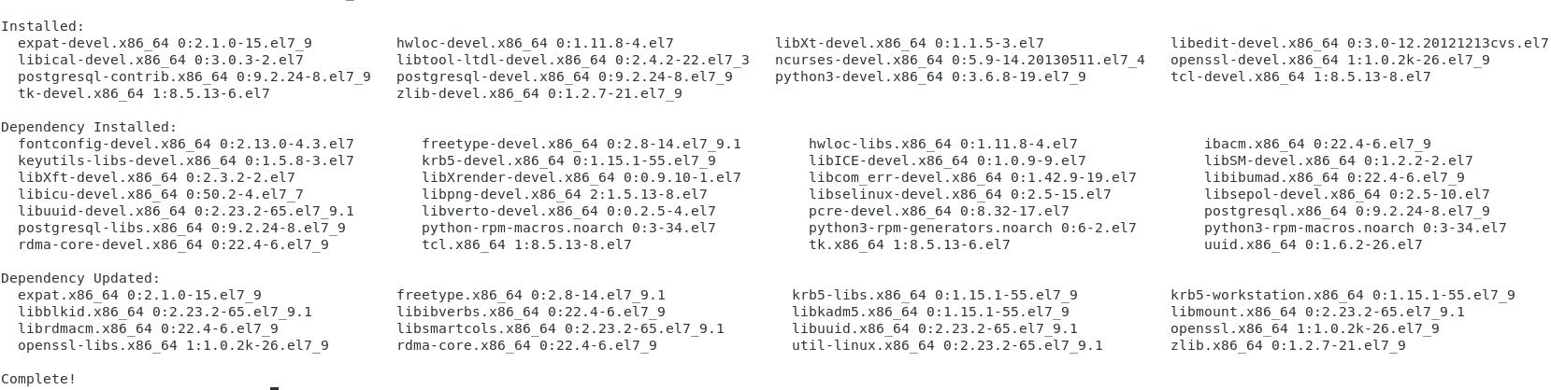

**# rpmbuild -ba openpbs.spec**

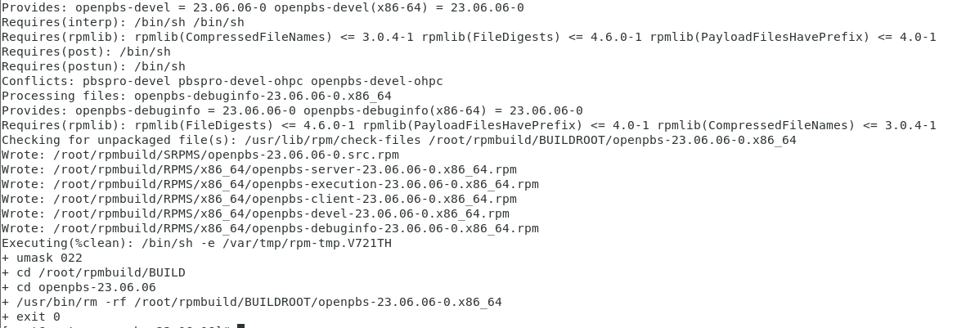

**#** **cd**

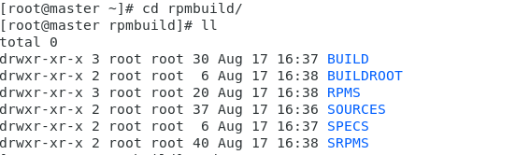

**# cd rpmbuild/RPMS/x86_64/**

**# yum install openpbs-server-23.06.06-0.x86_64.rpm -y**

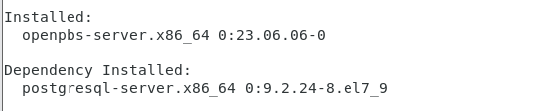

**# chmod 4755 /opt/pbs/sbin/pbs_iff /opt/pbs/sbin/pbs_rcp**

**# systemctl start pbs.service && systemctl enable pbs.service**

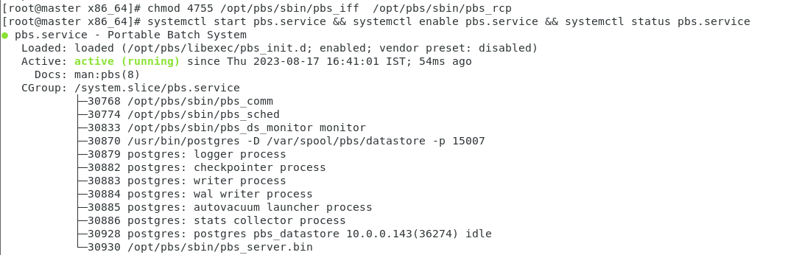

**# . /etc/profile.d/pbs.sh**

**# qstat -B**

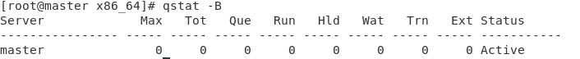

**On Node 1**

**# yum install git -y**

**# git clone** [**https://github.com/openpbs/openpbs.git**](https://github.com/openpbs/openpbs.git)

**# cd openpbs/**

**# yum install autoconf autoconf-2.69 automake libtool -y**

**# yum install libtool-ltdl-devel hwloc-devel libXt-devel libedit-devel libical-devel ncurses-devel postgresql-devel postgresql-contrib python3-devel tcl-devel tk-devel zlib-devel expat-devel openssl-devel -y**

**# ./configure**

**# mkdir /opt/pbs/**

**# ./configure --prefix=/opt/pbs/**

**# make**

**# make install**

**On Master**

**# scp /opt/pbs/etc/pbs.sh root@n001:/opt/pbs/etc/**

**On Node 1**

**# . /opt/pbs/etc/pbs.sh**

**# chmod +x /opt/pbs/etc/pbs.sh**

**# export PATH=${PATH}:/opt/pbs/bin**

**On Master**

**# scp /etc/pbs.conf root@n001:/etc/**

**On Node 1**

**# vi /etc/pbs.conf**

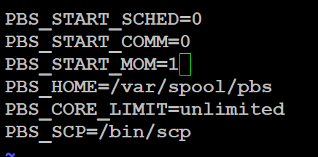

**# systemctl start pbs && systemctl enable pbs && systemctl status pbs**

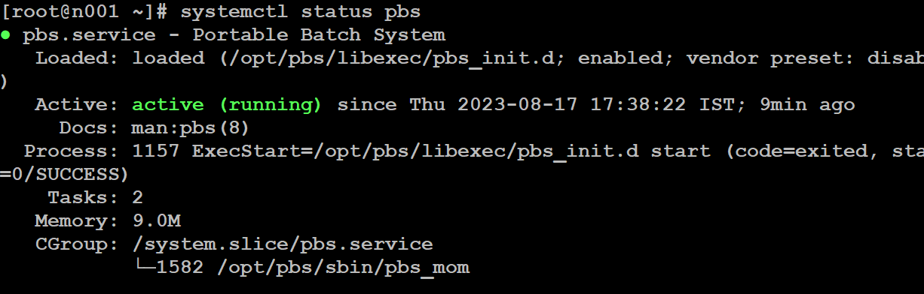

**On Master & node2**

**# yum install nfs-utils \***

**# systemctl start nfs && systemctl enable nfs**

**On Master**

**# chmod 777 /root/rpmbuild/RPMS/x86_64/**

**# vi /etc/exports**

root/rpmbuild/RPMS/x86_64/ * (rw,sync,no_root_squash)



**# exportfs –avr**

**On Node2**

**# mkdir /root/pbs**

**# mount -t nfs 192.168.44.144:/root/rpmbuild/RPMS/x86_64/ /root/pbs**

**# df -H**

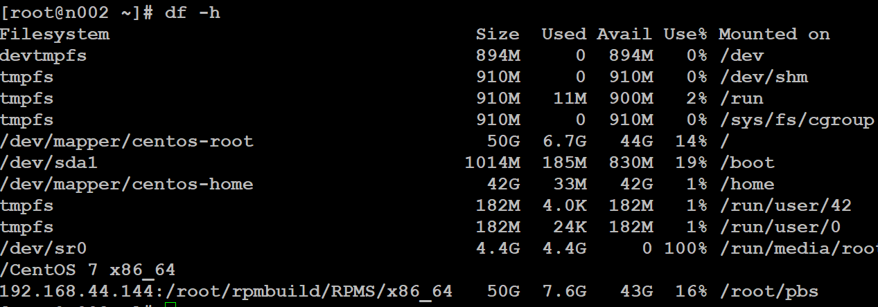

**# cd pbs/**

**# yum install openpbs-execution-23.06.06-0.x86_64.rpm**

**On Node1**

**# rsync /etc/pbs.conf root@n002:/etc/**

**On Node2**

**# systemctl start pbs.service**

**# systemctl enable pbs.service**

**# vi /var/spool/pbs/mom_priv/config**

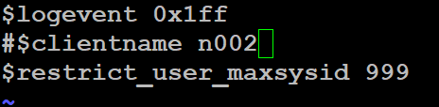

**# systemctl restart pbs.service**

**On Node1**

**# vi /var/spool/pbs/mom_priv/config**

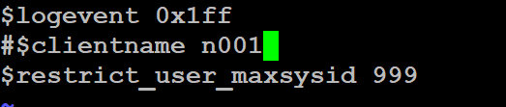

**# systemctl restart pbs.service**

**On Master**

**# vi /var/spool/pbs/server_priv/nodes**

n001 np=1

n002 np=1

**# qmgr**

Now you will get qmgr shell

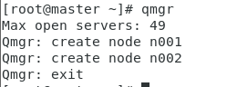

**# pbsnodes –a** -------> list all nodes & their attributes

